Feed MeLIFESTYLE•RESTAURANTS
Montauk restaurant
Crow's Nest impresses with Chef John Yashinowsky, renovations
Updated August 26, 2015 1:09 PM
By PETER M. GIANOTTI peter.gianotti@newsday.com

John Yashinowsky cooks the last good meal on Long Island.
He's doing it at the Crow's Nest, just west of the Montauk Lighthouse. Yashinowsky started his career there as a dishwasher decades ago. This year, he returned as executive chef. In between, he was a private chef, plus chef-owner of the departed Caswell's in Montauk and chef at Fresno in East Hampton, earning two 2-star ratings in Newsday.
The Crow's Nest has undergone a stunning makeover in recent years, with major renovations in the dining room, the hotel, and the style. The cloudy fish tank with it's lonely little shark is long gone. And the restaurant now is a magnet, for its sunset views, lively social scene, and very good food.

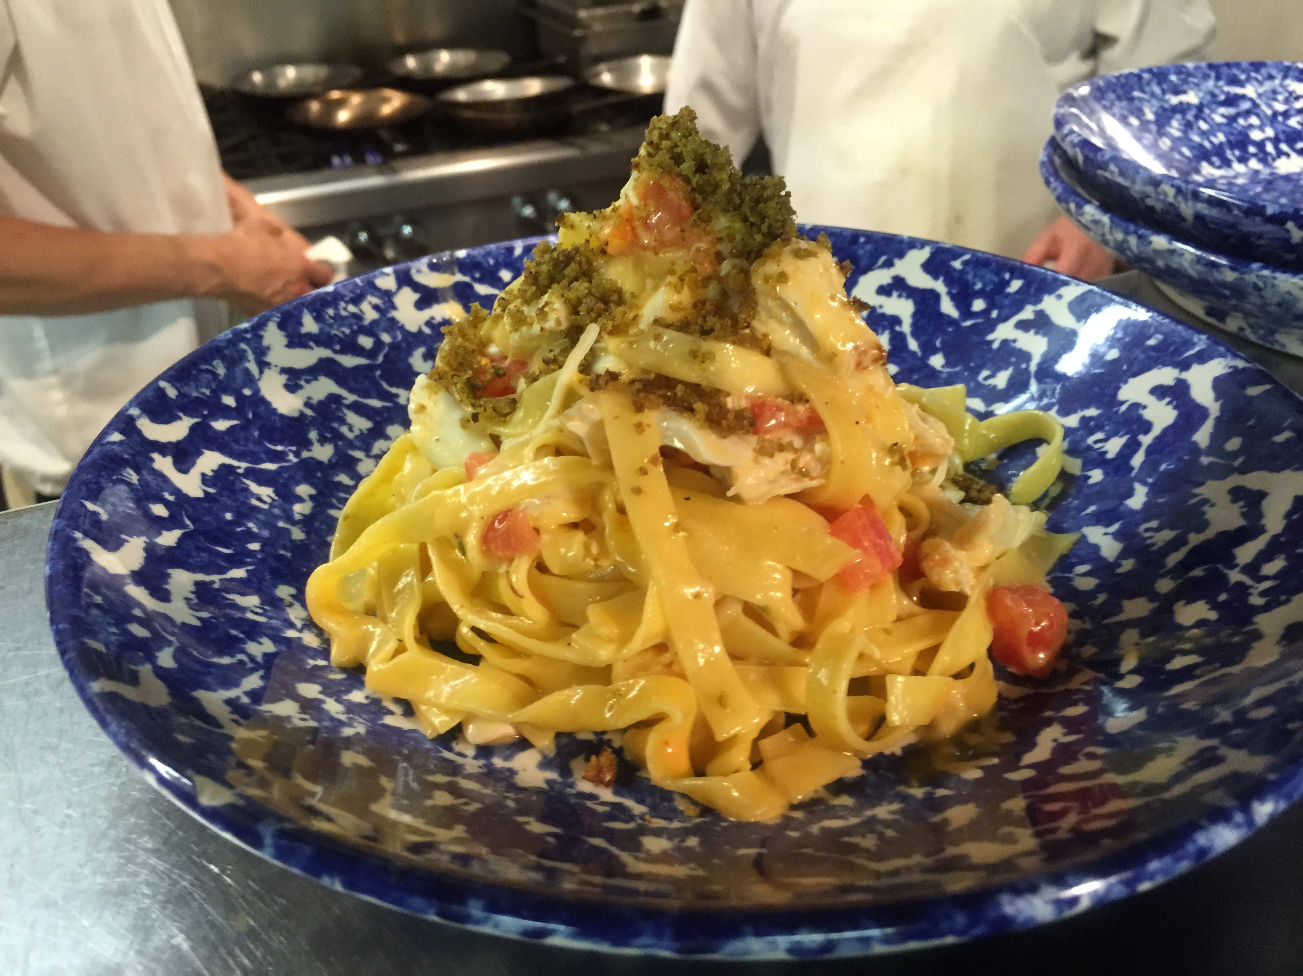
Blue crab claw tagliatelle with Calabrian chilies, lemon and olive oil is served at the Crow's Nest in Montauk.

Yashinowsky's standouts include tagliatelle with blue crab claw meat, lemon, olive oil and a rush of Calabrian chilies. It's spicy, subtle, and very satisfying. Montauk striped bass gets a spark from harissa that's balanced with a note of honey and black quinoa. Curried vegetables also are recommended, aromatic and full-flavored. Start with fluke crudo accented with black Hawaiian salt; a local kale salad with pine nuts and Parmesan; or fresh ricotta with local honey and grilled bread. Olive oil cake tops the desserts. All this adds up to a hefty tab. But Yashinowsky's fare and the revived restaurant are worth the cost and the drive.
Crow's Nest is at 4 Old West Lake Dr., Montauk, 631-668-2077, crowsnestmtk.com

